Bahria University,

Karachi Campus

LAB EXPERIMENT NO.

____**02**_____

LIST OF TASKS

|  |  |
| --- | --- |
| TASK NO | OBJECTIVE |
| **1** | **Which type of sorting you want to apply? Create a menu having the following options:**   * 1. **Bubble Sort Method**   2. **Selection Sort Method**   3. **Insertion Sort Method**   **Implement using methods.** |
| **2** | **Implement Selection sort and print string array data in descending order.** |
| **3** | **A Detox chemical Industry has a list of chemicals along with their concentration and Volume. Your task is to list down the name of chemicals in descending order based on their Volume. In order to fulfil the task you have to select any of the sorting method taught in todays lab with proper reasoning of usage of that algorithm.** |
| **4** | **You have to write a program which take input from the user and place the value on correct location in ascending order.** |
| 5 | Write a program which take N numbers of grocery items from user along with their price. Your main task is to display the items in sorted format. Then allow user to search for any of the item from that list by using name of the item. |

Submitted On:

____05/10/2022____

(Date: DD/MM/YY)

**Task No. 1 : Which type of sorting you want to apply? Create a menu having the following options:**

1. **Bubble Sort Method**
2. **Selection Sort Method**
3. **Insertion Sort Method**

**Implement using methods.**

**Solution:**

static void bubble(int[] array){

int n = array.Length;

int k;

for (int m = n; m >= 0; m--){

for (int i = 0; i < n - 1; i++){

k = i + 1;

if (array[i] > array[k]){

int temp;

temp = array[i];

array[i] = array[k];

array[k] = temp;}}}

for (int m = 0; m < array.Length; m++){

Console.Write(array[m] + " ");}

Console.ReadLine();}

static void selection(int[] arr){

int temp, smallest;

for (int i = 0; i < arr.Length - 1; i++)

smallest = i;

for (int j = i + 1; j < arr.Length; j++){

if (arr[j] < arr[smallest]){

smallest = j;}}

temp = arr[smallest];

arr[smallest] = arr[i];

arr[i] = temp;}

for (int m = 0; m < arr.Length; m++){

Console.Write(arr[m] + " ");}

Console.ReadLine();}

static void insertion(int[] Array){

for (int i = 0; i < Array.Length - 1; i++){

for (int j = i + 1; j > 0; j--){

if (Array[j - 1] > Array[j]){

int temp = Array[j - 1];

Array[j - 1] = Array[j];

Array[j] = temp;}}}

for (int m = 0; m < Array.Length; m++){

Console.Write(Array[m] + " ");}

Console.ReadLine();}

static bool Menu(int[] a) {

Console.WriteLine("\n\nWHICH TYPES OF SORTING YOU CHOOSE");

Console.WriteLine("1) BUBBLE SORT \n2) INSERTION SORT\n3) SELECTION SORT");

Console.Write("Select any One ? ");

switch (Console.ReadLine()){

case "1":

Console.WriteLine("\nBUBBLE SORT");

bubble(a);

return true;

case "2":

Console.WriteLine("\nINSERTION SORT ");

insertion(a);

return true;

case "3":

Console.WriteLine("\nSELECTION SORT ");

selection(a);

return true;

default:

return false;}}

static void Main(string[] args){

int[] arr = { 46,20,100,89,36,75,18,33,98,26,86,51};

Console.Write("Unsorted Array = ");

for(int i = 0; i<arr.Length; i++){

Console.Write(arr[i]+" ");}

bool a = true;

while (a){

a = Menu(arr);}}

**Output:**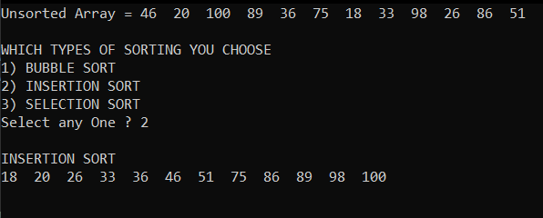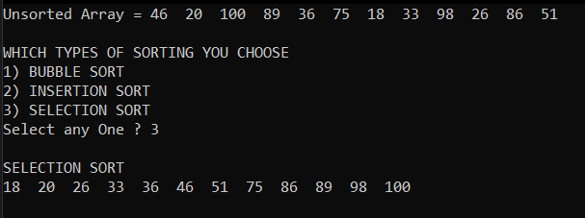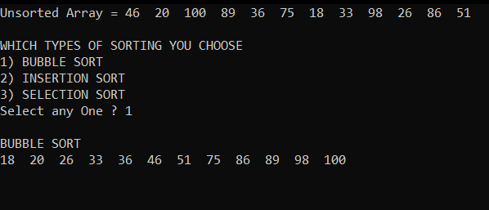

**Task No. 2 : Implement Selection sort and print string array data in descending order.**

**Solution:**

int smallest;

string temp;

for (int i = 0; i < array.Length; i++){

smallest = i;

for (int j = (i + 1); j < array.Length; j++){

if (array[smallest][0] > array[j][0]){

smallest = j;}}

temp = array[smallest];

array[smallest] = array[i];

array[i] = temp;}}

static void Main(string[] args){

Console.Write("Enter The Sixe Of Array : ");

int size = int.Parse(Console.ReadLine());

string[] array = new string[size];

for (int i = 0; i < array.Length; i++){

Console.Write("Enter Value At {0} Index : ", (i + 1));

array[i] = Console.ReadLine().ToLower();}

Console.Clear();

for (int i = 0; i < array.Length; i++){

Console.WriteLine("\t {0}",array[i]);}

Console.WriteLine("After Sorting In Decending Order \n");

SelectionSort(array);

for (int i = array.Length-1; i >= 0; i--){

Console.WriteLine("\t {0}", array[i]);}

**Output:**

**Task No. 3 : A Detox chemical Industry has a list of chemicals along with their concentration and Volume. Your task is to list down the name of chemicals in descending order based on their Volume. In order to fulfil the task you have to select any of the sorting method taught in todays lab with proper reasoning of usage of that algorithm.**

**Solution:**

int[] vol , conc;

string[] name;

Console.Write("How many chemical which you buy ? ");

int n = int.Parse(Console.ReadLine());

vol = new int[n];

conc = new int[n];

name = new string[n];

for (int i = 0; i < n; i++){

Console.Write("\nEnter Name : ");

name[i] = Console.ReadLine();

Console.Write("Enter Volume : ");

vol[i] = int.Parse(Console.ReadLine());

Console.Write("Enter Concentraion : ");

conc[i] = int.Parse(Console.ReadLine());}

for (int i = 0; i < n - 1; i++){ for (int j = i + 1; j > 0; j--){

if (vol[j - 1] < vol[j]) {

int temp = vol[j - 1];

vol[j - 1] = vol[j];

vol[j] = temp;

string temp1 = name[j - 1];

name[j - 1] = name[j];

name[j] = temp1;

int temp2 = conc[j - 1];

conc[j - 1] = conc[j];

conc[j] = temp2; }}}

Console.WriteLine("\n\nNAME\t\tVOLUME\t\tCONC");

for (int i = 0; i < n; i++){

Console.WriteLine("{0,-16} {1,-15} {2}", name[i], vol[i], conc[i]);}

**Output:**

**Task No. 4 : You have to write a program which take input from the user and place the value on correct location in ascending order.**

**Solution:**

Console.Write("Enter length of Array : ");

int n = Convert.ToInt32(Console.ReadLine());

Console.WriteLine("\nEnter Numbers :");

int[] arr = new int[n];

for (int i = 0; i < arr.Length; i++) {

arr[i] = Convert.ToInt32(Console.ReadLine()); }

for (int j = 0; j < arr.Length; j++){

int index = j;

for (int k = j; k < arr.Length; k++) {

if (arr[index] > arr[k]) {

index = k; }}

int temp = arr[index];

arr[index] = arr[j];

arr[j] = temp;}

Console.Write("\nSorting number is : ");

for (int l = 0; l < arr.Length; l++) {

Console.Write(arr[l]+" "); }

Console.ReadLine();

**Output:**

**Task No. 5 : Write a program which take N numbers of grocery items from user along with their price. Your main task is to display the items in sorted format. Then allow user to search for any of the item from that list by using name of the item.**

**Solution:**

static void Main(string[] args){

Console.Write("Enter number of grocery items = ");

int num = int.Parse(Console.ReadLine());

String[,] groceryItems = new string [num,2];

for(int i = 0; i<num; i++){

Console.Write("\nEnter Grocery Name : ");

groceryItems[i, 0] = Console.ReadLine();

Console.Write("Enter Grocery Price : ");

groceryItems[i, 1] = Console.ReadLine();}

Console.WriteLine("\n1) Search Item\n2) Display Item along with Grocery Name\n3) Display Item along with Grocery Price");

Console.Write("\n\tSelect any option : ");

int choice = int.Parse(Console.ReadLine());

switch (choice){

case 1:

Console.Write("\n\nEnter Grocery Item for Searching : ");

String search = Console.ReadLine();

for (int i = 0; i < num; i++){

if (groceryItems[i, 0] == search){

Console.WriteLine("\n\tGrocery Item = " + search);

Console.WriteLine("\tGrocery Price = " + groceryItems[i, 1]);

break;}}

break;

case 2:

Console.WriteLine("\n--------------------------------");

Console.WriteLine("| Grocery Items\t |\tPrice |");

Console.WriteLine("--------------------------------");

String[] items_Sort = new string[num];

for (int i = 0; i < num; i++) {

items_Sort[i] = groceryItems[i, 0];}

Array.Sort(items_Sort);

for (int i = 0; i<num; i++){

for(int j = 0; j<num; j++){

if (items_Sort[i] == groceryItems[j,0]){

Console.WriteLine("| {0,-15}|\t{1,-6}|", groceryItems[j, 0], groceryItems[j, 1]);}}

if(i == num - 1){

Console.WriteLine("--------------------------------");}}

break;

case 3:

Console.WriteLine("\n--------------------------------");

Console.WriteLine("| Grocery Items\t |\tPrice |");

Console.WriteLine("--------------------------------");

int Price1 , Price2;

for (int i = 0; i < num - 1; i++){

for (int j = i + 1; j > 0; j--){

Price1 = int.Parse(groceryItems[j - 1, 1]);

Price2 = int.Parse(groceryItems[j , 1]);

if (Price1 > Price2){

String tempName = groceryItems[j - 1, 0];

String tempPrice = groceryItems[j - 1, 1];

groceryItems[j - 1, 0] = groceryItems[j, 0];

groceryItems[j - 1, 1] = groceryItems[j, 1];

groceryItems[j, 0] = tempName;

groceryItems[j, 1] = tempPrice;}}}

for(int i = 0; i<num; i++){

Console.WriteLine("| {0,-15}|\t{1,-6} |", groceryItems[i, 0], groceryItems[i, 1]);

if (i == num - 1){

Console.WriteLine("--------------------------------");}}

break;

default:

Console.WriteLine("\n\nYou Press Wrong Key");

break;}}

**Output:**



